Lab 5: Chemotaxis and Pattern Formation in Tetrahymena
(C.U.R.E. Week 1 of 2)
Learning Goals:
1. Develop testable hypotheses related to chemotaxis and bioconvection in Tetrahymena
2. Modify existing methods to test your hypotheses
3. Perform experiments and collect accurate data
4. Analyze and interpret experimental results

Introduction:

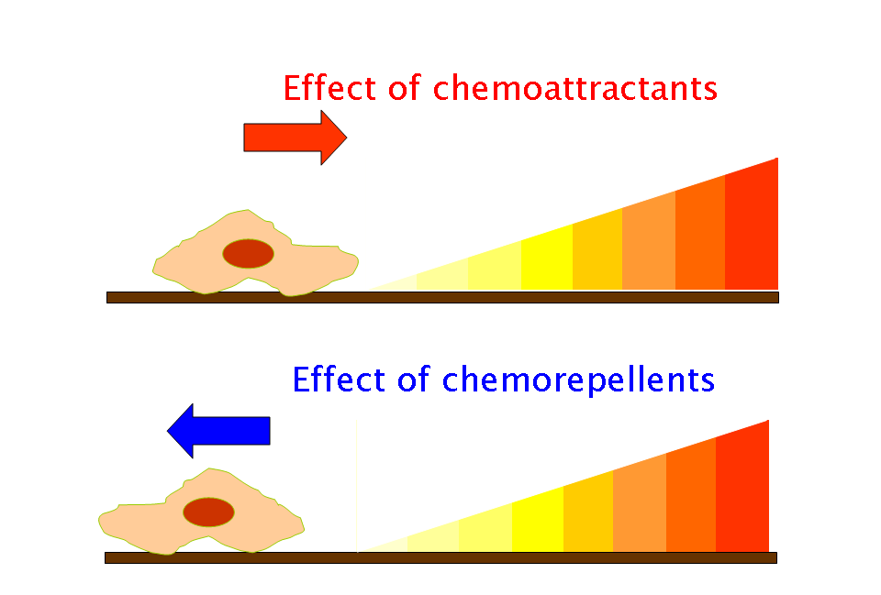
Tetrahymena thermophila swims using its cilia, at times moving in a straight line, and at other times making turns. This movement is known as taxis: the directed movement towards or away from a stimulus. Taxis can be in response to light (phototaxis), chemical signals (chemotaxis), or gravity (geotaxis) and can be directed toward (positive) or away (negative) from the source of the stimulus. The attracting chemotactic agent alters the frequency of turning as Tetrahymena move directly towards the source, following the increasing concentration gradient. Tetrahymena will tend to swim towards a chemoattractant (such as food) and away from a chemorepellent, which signals danger (Figure 1). While these changes are not easy to see immediately upon adding a substance into their environment, if you wait a few minutes, the cumulative effect of changes in the behavior of several cells will become apparent. In this chemotaxis assay, cells will be given an opportunity to swim towards or away from the ‘test substance’ (independent variable) you/your group selected in your research plan.
Figure 1. Chemotaxis. Image by Kohlasz is licensed under CC BY 3.0.

Pre-Lab Questions - Chemotaxis:

- Why do we only use starved Tetrahymena cells for our chemotaxis experiments?

- Define chemotaxis. Besides chemicals (organic or inorganic), what other types of signals (at least two) can organisms respond to by moving towards or away?

- What structure do Tetrahymena use to move?

- Why have Tetrahymena (and many other organisms) evolved to use chemotaxis?

Procedure – Chemotaxis:

Procedure – Chemotaxis:
- Record the name of your group’s test substance/extract here:_____________________________
- Use a Sharpie marker (provided) to label a glass test tube with your group’s initials, lab day/time and the substance being tested. Write clearly (you will re-use your extract for the next two labs).
- Use a clean graduated cylinder to place 3 mL of Tris solution into your tube.
- Measure ~0.3g of your substance using an electronic balance and weigh boat (if it’s a solid). For liquid substances, pipette 0.3 mL (300 µL). If your substance isn’t already in a small granular form (such as ground coffee), use the provided mortar and pestle to grind it up. Place the 0.3g into your tube containing Tris.
- Mix your test tube contents using a glass stirring rod (if your test substance is a solid) until you have a homogeneous mixture. Some solids may not completely dissolve with stirring, in which case a hot plate can be used to gently warm your test tube while stirring (do not heat too much or too long, or your solution will evaporate). Liquid test substances can be triturated (mixed by pipetting up and down using a micropipette) or with a stirring rod. Proceed to the next step once your solution is well-mixed and is at room temperature.
- Locate the 96-well plate on your group’s tray. Using a p1000 micropipette, carefully place 200 µL of starved Tetrahymena into wells A1, C1 and E1 (pipette just below the surface of the culture solution), 150 µL of extract into wells A3, C3 and E3, 150 µL of proteose peptone into wells B3, D3 and F3, and 100 µL of NEFF media into wells A5 through F5. Be sure to use a new, sterile blue tip when switching between solutions. Your plate should look something like Figure 2 (next page):
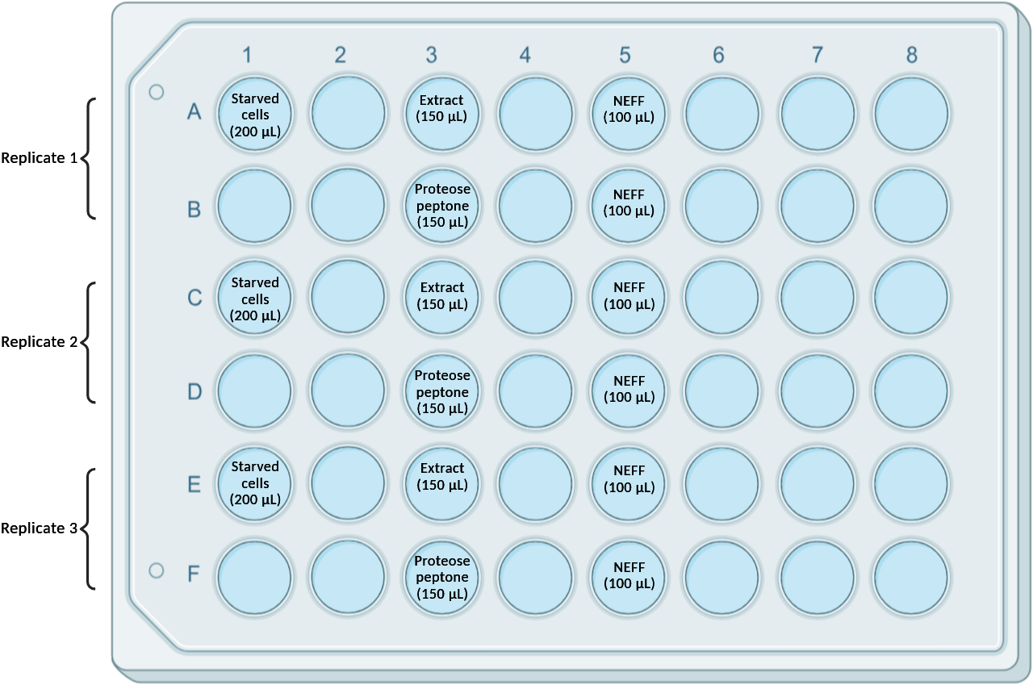
Figure 2. 96-well setup for chemotaxis assay. ‘Extract’ refers to your test substance (independent variable). Proteose peptone serves as a positive control (chemoattractant). Created with BioRender.com

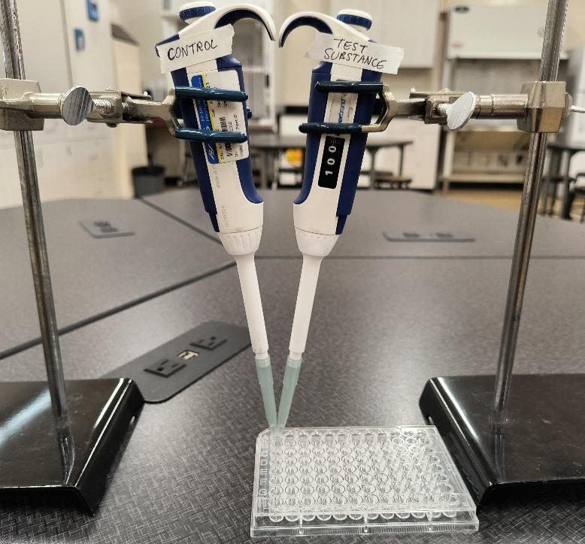
- *TIME SENSITIVE STEP – READ AHEAD* Use a p1000 pipette to draw up 100 µL of test substance/extract from well A3 (Column 3); label this micropipette “test substance” with tape as shown in Figure 3. Place the micropipette in a clamp on a ring stand and lower it so the tip rests in well A1, containing Tetrahymena cells (Column 1). Do not push the plunger and mix the extract into the cells; just leave the tips in the wells and give the cells time to decide whether to remain in the well or move into the tip containing extract. Simultaneously (and working quickly), repeat this setup, this time using a second micropipette/tip containing 100 µL of proteose peptone from well B3. Label this micropipette “control” (again, use tape). Once this 2nd tip is set up, start a timer and leave it set up for 10 minutes (do this soon after resting the tips in the well of Tetrahymena cells). Get a microscope and slide ready while you wait.

Figure 3. Photo of chemotaxis setup. Micropipettes should be labeled either “test substance” or “control” using tape.

- After 10 minutes (and with a partner), remove each pipette from well A1 and pipet the contents of the tip into well A5 (if extract) and well B5 (if positive control) in Column 5. This time you should push the plunger of each and gently mix the contents of the tip into the corresponding well containing NEFF medium. Note: mix slowly to avoid splashing (losing volume) or creating bubbles (which can kill the Tetrahymena). Repeat Steps 7-8 for each row/replicate of wells on your plate. Be sure to use well C1 for your ‘Replicate 2’ samples (wells C3 and D3) and well E1 for your ‘Replicate 3’ samples (wells E3 and F3). Focus on pipetting to and from the correct wells, and double-check your lab partners as needed.
- While completing Steps 7-8 (and monitoring the 10-minute incubation periods), remove 3 µL of sample from each of the mixed solutions in Column 5 and count the number of Tet. cells in the drop. Place a new, sterile yellow tip on your 2-20 µL pipette and use it to draw up 3 µL from each individual well (once you’ve completed the chemotaxis assay for that replicate). Place this volume onto a microscope slide without a cover slip (Note: 3 µL is a tiny volume and can be hard to see; your instructor should demonstrate what this looks like when pipetted correctly).
- Place your prepared slide onto the microscope stage. Using the lowest power lens (4x) on your scope, count the number of cells you observe in the drop. You and your partner(s) should agree on the count. You will need to work fairly quickly since 3 µL is a very small amount and will begin to evaporate, killing the cells. If you see a really large number of cells, try counting about half the drop and multiplying by 2, or a quarter of the drop and multiplying by 4. (If you are using this method, try it at least twice to make sure you’re getting about the same results each time). Note that proteose peptone is a positive control/chemoattractant. Repeat this 3 times (i.e., count cells in 3 different droplets) from each well in Column 5. Record the count(s) for your group in the table below:

Table 1. Chemotaxis assay – cell counts.
Solution | Replicate 1 cell counts (per 3 µL)  (Wells A5 and B5) |  |  | Replicate 2 cell counts (per 3 µL)  (Wells C5 and D5) |  |  | Replicate 3 cell counts (per 3 µL)  (Wells E5 and F5) |  |  | Average cell count (per 3 µL)
Extract:__________
(Wells A5, C5 and E5)
Positive control
(Wells B5, D5 and F5)

Note: If you find that there are too many quickly moving cells to accurately count, try adding 3 µL of Detain (located at the instructor bench) right next to your 3 µL drop. Mix the drops together using your pipette tip. You do not need to adjust your cell counts for the added volume, since Detain does not contain any cells.

Your instructor will ask you to input your data into a ‘Chemotaxis data analysis’ file. Use this file to determine both percent effectiveness and the chemotaxis index of your test substance:

Chemotaxis index (write value here): _____________

Percent effectiveness: _____%$\frac{(Positive Control Cell Count - Extract Cell Count)}{(Positive Control Cell Count)} *100$

CLEAN UP: Save your group’s extract/substance (you will need it for next week). Seal your tube with Parafilm and place it in your lab section’s designated tube rack (to be stored in the fridge). Rinse your 96-well plate (only the used wells) with DI water, then 70% ethanol over a sink. Wipe any excess liquid from the used wells using a Kimwipe and set the plate face down on a paper towel/Kimwipe on your tray. Discard used slides in the labeled plastic bin. Save all Tetrahymena culture tubes for the next lab section. Return Detain tubes to the instructor bench, and dispose of gloves in regular trash bins.

Lab 5 Part 2: Bioconvection (Pattern Formation)
Like many unicellular, motile organisms, Tetrahymena spontaneously form a honeycomb-like pattern when left undisturbed in laboratory containers (as long as a minimum cell density of ~1.5x10⁵ cells/mL and minimum volume depth of 2mm is present – these requirements will be met by default for your group’s experiment today). These requirements were first described by Loefer and Medferd in their 1952 article, “Concerning Pattern Formation by Free-Swimming Microorganisms”. Here are some other key observations/data from their paper:
- Pattern formation occurs after ~8 seconds (assuming no confounding factors)
- The pattern develops within a pH range of 4.5-8.2 and is distinctly inhibited at pH 8.6
- Osmotic pressure has no effect on pattern formation through 0.075M NaCl, but is ‘markedly inhibited’ at 0.15 M; organisms agglutinated rapidly at higher concentrations
- The rate of pattern formation decreases and the pattern itself becomes progressively finer/sharper in direct proportion to a decrease in temperature
- In general, inhibition of pattern formation and pattern sharpness directly correlates with factors that affect the motility of Tetrahymena; these include (but are not limited to) anaerobic conditions for prolonged periods of time, addition of reducing agents until motility is affected, advanced age (of cells), low temperature, and high osmotic pressure

This pattern forms due to “negative gravitaxis”, or the upward movement of Tetrahymena against the force of gravity. As the individual Tetrahymena swim upwards, they tend to form random clumps near the surface of their liquid environment. The density of these clumps of cells becomes too great for the upward exertions of the Tetrahymena to overcome. These clumps eventually fall downward in columns, which creates the pattern/network we observe. This process of up-swimming and down-falling is called bioconvection. The honeycomb pattern will disappear momentarily when the contents of the container are agitated, but will reappear after the medium settles back down. Environmental factors (besides gravity) can influence how quickly the pattern reappears, however there are few studies on this subject; this gives you a unique opportunity to do original research.
Your goal in this exercise is to examine at least one factor (independent variable) that might affect bioconvection in Tetrahymena. The tables/space at the end of this protocol are there to help you organize your data. Remember that your primary dependent variable in this lab will be pattern formation time; additionally, you should observe how well-defined/sharp the pattern is. You may also want to take a photo and/or video of your group’s petri dish to include in your Results section.

Please try to be as accurate and consistent as possible in your methods and measurements – your data (and its analysis) will be an important part of your C.U.R.E. report.

Pre-Lab Questions - Bioconvection:

- What are the four minimum requirements for pattern formation described by Loefer and Medferd?

- Briefly describe 2-3 other motile, unicellular microorganisms that exhibit bioconvection (there are several, including many bacteria!)

Procedure – Bioconvection:
- Place your plate culture on an even surface (e.g. lab bench/counter) and allow the Tetrahymena to form a honeycomb pattern; this will be most visible when placing the plate on a dark surface. Do not proceed until you notice a clear, well-defined pattern. This honeycomb pattern typically forms in under a minute. Ask the instructor to take a look at your plate if you’re having issues.
- In this activity, you are also being asked to describe the degree of pattern definition/sharpness you observe. The honeycomb pattern should be distinct/sharp in an untreated culture plate, but this sharpness may decrease after the Tetrahymena are exposed to your independent variable.
- With a timer/stopwatch ready, disrupt the pattern by rocking the plate in a ‘north, south, east, west’ motion. Be as consistent as possible when doing these motions, as you will otherwise introduce systematic error into your results. Have the same group member perform the disruption for ALL plates and replicates. Start your timer the moment you finish disrupting the pattern and stop your timer once you can distinguish a clear pattern again. Record your pattern formation time and observations in Table 2 below, under the Replicate 1 column.
- Repeat Step 3 twice to obtain your 2nd and 3rd replicate for the control plate; enter your results in Table 2. Again, be as consistent as possible when performing the disruption. When finished, calculate the average pattern formation time by adding all control plate replicate times together and dividing by 3; write the average in the space below Table 2.
- Using the same ‘control’ plate, expose your plate to your independent variable. If adding a solution/test substance, determine the volume you need to add to achieve your final concentration (remember that each plate initially contains 8 mL of culture). Note that you may also need to add additional culture to your plate to achieve your desired final concentration. Please refer to the ‘Bioconvection Concentration Calculator’ file for assistance with this.
- As noted above, adjust/dilute your treatment concentration (if needed) and wait 5 minutes to allow exposure to the test substance; then repeat the disruption process. Record your results in Table 3 for your test plate/cultures.

NOTE: For your control plate/conditions, you should keep timing until you see a clear, well-defined pattern, however your test plate (the one you will treat with a substance or environmental factor) may not re-form a clear (or any) pattern, depending on the effects of your independent variable. Your preliminary research (and parameters from the Loefer/Medferd paper) should inform the final concentration/environmental conditions you choose to test.

Table 2. Bioconvection results – control plate.
Observations | Replicate 1 | Replicate 2 | Replicate 3
Pattern formation time (seconds)
Pattern definition (poorly defined, moderately defined or well-defined)

Control plate average formation time (sec): __________

Table 3. Bioconvection results – test plate.
Observations | Replicate 1 | Replicate 2 | Replicate 3
Pattern formation time (seconds)
Pattern definition (poorly defined, moderately defined or well-defined)

Test plate average formation time (sec): __________
Use the space below to record additional data or observations for your Pattern Formation Experiment.
Additional Data:

Observations:

Post-Lab Questions – Chemotaxis and Bioconvection

- Which compounds tested lead to attraction? Which acted as repellents? Hypothesize why each of these compounds had the effect they did.

- We have often talked about chemotaxis as being important for unicellular organisms, however certain cell types in multi-cellular organisms (including humans) do engage in chemotaxis. Propose a type of cell that would engage in chemotaxis, explain why this cell would do chemotaxis, and design an experiment to test your hypothesis.

- Reflect on your Chemotaxis results. Was your hypothesis supported or rejected, and why? How would you revise your hypothesis based on your results?

- Reflect on your Bioconvection (Pattern Formation) results. Was your hypothesis supported or rejected, and why? How would you revise your hypothesis based on your results?

